

MINI PROJECT
DEVELOPING A PASSPORT GENERATOR
USING PYTHON PROGRAMMING

SUBMITTED BY: SUBMITTED TO:
Name: Simranjeet kaur Dhillon
Roll Number: 24BSC10019 Miss Monika
Course / Semester: BSC(CS) /5TH

CERTIFICATE
This is to certify that the mini project report entitled “Developing a Passport Generator Using Python” has been prepared by _____________simranjeet kaur _________________, Roll Number ______24bsc10019____________, as part of the academic requirements for _____________bsc cs _________________. The project demonstrates basic Python programming concepts including functions, user input, date validation, random value generation, dictionaries, loops, conditional statements, and file handling.
Supervisor’s Signature: ______________________
Date: __________________ Place: __________________

DECLARATION
I declare that this report titled “Developing a Passport Generator Using Python” has been prepared for educational purposes. The code and explanations are presented as a beginner-level programming project. The generated identifier and record are demonstrations only and are not official government-issued passport information. Any personal details used in testing should be fictional or used with the person's permission.
Student Signature: ______________________

ACKNOWLEDGEMENT
I would like to express my sincere gratitude to my teacher/supervisor for guidance and support during the preparation of this project. I am also thankful to my institution for providing an opportunity to apply the concepts of Python programming to a practical mini project. This work helped me understand functions, input validation, random number generation, dictionaries, loops, conditional statements, and file handling.

TABLE OF CONTENTS
- Abstract
- 1. Introduction
- 2. Problem Statement
- 3. Aim and Objectives
- 4. Scope of the Project
- 5. Existing System and Proposed System
- 6. Feasibility Study
- 7. Hardware and Software Requirements
- 8. System Design and Architecture
- 9. Algorithm and Flowchart Description
- 10. Methodology / Working
- 11. Source Code
- 12. Detailed Code Explanation
- 13. Sample Run and Output
- 14. File Handling
- 15. Testing and Test Cases
- 16. Advantages
- 17. Limitations
- 18. Security, Privacy, and Ethical Considerations
- 19. Future Scope
- 20. Conclusion
- 21. Learning Outcomes
- 22. Viva Questions and Answers
- 23. References

ABSTRACT
The Passport Generator Using Python is a beginner-level console application that collects a user's basic details, validates the date of birth, generates a random sample identifier, displays the record, and gives the user the option to save the record in a text file. The application uses Python's built-in random and datetime modules, along with functions, dictionaries, loops, conditional statements, exception handling, and file operations. The project demonstrates how small tasks can be divided into reusable functions and how user input can be organized into a structured record. The generated number is only a random demonstration identifier. The program is not connected to a passport authority, does not verify identity, and cannot create an official passport or valid passport number.
The project is useful for learning the basic software development cycle: identifying a problem, defining requirements, designing the program, implementing the code, testing different inputs, and considering future improvements such as stronger validation, a graphical interface, and database storage.

1. INTRODUCTION
Python is a high-level, interpreted programming language known for readable syntax and a large standard library. It is widely used for automation, data processing, web development, education, and scripting. Because Python code is relatively easy to read, it is suitable for students who are learning programming.
This project applies Python to the task of creating a sample passport-style record. When the program runs, it asks for a full name, date of birth, nationality, and address. It checks the date using the datetime module. If the date is valid, the program generates a sample identifier consisting of two uppercase letters and seven digits. The details are then displayed in the terminal, and the user can choose to save them to a text file.
The purpose is educational: to practise the core concepts of Python in one small application. The project does not represent an official passport service and should not be used to create or imitate an official identity or travel document.

2. PROBLEM STATEMENT
Students learning Python often understand individual concepts such as input(), functions, dictionaries, conditions, and file handling separately, but need practice combining them into a complete application. A small record generator provides a practical way to connect these concepts. Without a structured program, sample records may be entered inconsistently or copied manually. This project organizes the entered details in a fixed format and optionally stores them in a text file.

2.1 Problem addressed
- Collect a small set of details through keyboard input.
- Check whether the date of birth is a valid calendar date in the required format.
- Create a random sample identifier for demonstration.
- Display the record in a clear, consistent format.
- Allow the user to save the sample record to a text file.

2.2 Boundaries of the problem
The program does not check a person's identity, eligibility, citizenship, or official passport status. It does not connect to government databases, submit applications, produce a passport booklet, or generate an official passport number.

3. AIM AND OBJECTIVES

3.1 Aim
To design and implement a simple Python program that collects basic information, validates the date of birth, generates a random sample identifier, displays the record, and optionally saves it to a text file.

3.2 Objectives
- Understand how to import and use Python standard-library modules.
- Use input() to collect information from the user.
- Use functions to divide the program into manageable tasks.
- Validate a date using datetime.datetime.strptime().
- Generate a random string using random.choices().
- Store related values in a dictionary.
- Use a for loop to display and save dictionary contents.
- Use if/else statements to control program flow.
- Use a try/except block to handle an invalid date.
- Write text to a file using a with statement.
- Test normal and invalid input cases and identify possible improvements.

4. SCOPE OF THE PROJECT
The current version includes the following functions:
- Console-based interaction: the user types details in the terminal.
- Basic date validation: the date must match YYYY-MM-DD and be a real calendar date.
- Sample identifier generation: two uppercase letters followed by seven digits.
- Record display: information is printed using field labels.
- Optional file saving: a text file is created only when the user answers yes.
- Modular code: separate functions are used for generating, collecting, displaying, and saving information.
The project is appropriate for a Python lab assignment or mini project. A future version could include a graphical user interface or database, but any real handling of identity information would require proper authorization, privacy safeguards, and compliance with applicable law.

5. EXISTING SYSTEM AND PROPOSED SYSTEM
Aspect | Manual / basic approach | Proposed Python project
Data entry | Details may be typed into an unstructured note. | Prompts guide the user through four fields.
Date checking | A date may be accepted without checking. | The program validates the date format and calendar date.
Identifier | A sample label may be typed manually. | A random demonstration identifier is generated.
Display | Formatting depends on the person entering it. | Fields are printed in a consistent order.
Storage | The record may need to be copied manually. | The user can save the record to a text file.
Official verification | Not provided. | Not provided; the project is a demonstration only.

5.1 Proposed system workflow
The proposed system accepts data, validates the date, creates a dictionary, displays the record, and asks whether to save it. If date validation fails, the function returns None and the main function does not display or save a record.

6. FEASIBILITY STUDY

6.1 Technical feasibility
The project is technically feasible because it uses standard Python features and requires no third-party packages, server, or internet connection. It can run on a computer with a compatible Python 3 installation.

6.2 Economic feasibility
The software cost is minimal because Python and common editors such as IDLE or Visual Studio Code can be used without purchasing a special development tool. A standard computer is sufficient.

6.3 Operational feasibility
The program is simple to operate. The user follows on-screen prompts and chooses whether to save the record. No advanced technical knowledge is required to run the program.

6.4 Schedule feasibility
The scope is small and suitable for a short academic assignment. The main tasks are writing the functions, running the program, testing valid and invalid dates, and documenting the results.

7. HARDWARE AND SOFTWARE REQUIREMENTS

7.1 Hardware requirements
- Desktop computer or laptop
- Keyboard and monitor/display
- Basic available storage space

7.2 Software requirements
- Operating system: Windows, macOS, or Linux
- Python 3
- Code editor or IDE such as IDLE or Visual Studio Code
- Terminal / command prompt

7.3 Python modules
Module / Feature | Purpose in the project
random | Selects uppercase letters and digits for a random sample identifier.
datetime | Checks that the date of birth follows the required date format and is a valid date.
input() | Reads the user's entries from the keyboard.
open() and with | Opens and safely closes the text file used to save the record.
Dictionary | Keeps labels and their associated values together.

8. SYSTEM DESIGN AND ARCHITECTURE

8.1 Input design
Input field | Example | Purpose
Full name | Aman Kumar | Stores the sample person's name.
Date of birth | 2003-06-15 | Stores date in year-month-day format.
Nationality | Indian | Stores the entered nationality.
Address | Chandigarh | Stores the entered address.
Save choice | yes / no | Determines whether the record is written to a file.

8.2 Processing design
- Read the four personal-detail fields.
- Attempt to parse the date using the format string %Y-%m-%d.
- If parsing raises ValueError, print an error message and return None.
- If parsing succeeds, generate a random sample identifier.
- Place the values in a dictionary.
- Display the dictionary contents.
- Ask the user whether to save the record and act on the answer.

8.3 Output design
The program prints the entered details and the sample identifier in the terminal. If the user chooses yes, the program creates a text file named using the identifier, such as passport_AB1234567.txt. The exact identifier will normally differ each time the program runs.

8.4 Architecture diagram (text description)
User
|
v
get_user_input()
|
+--> Validate date using datetime
| |
| +--> Invalid date --> Show error --> Stop record processing
|
+--> generate_passport_number()
|
v
Create dictionary
|
v
display_passport(info)
|
v
Ask: Save record?
/ \
yes no
| |
v v
save_passport() Show not saved
|
v
Text file created
This is a logical flow representation of the current program, not a government document-generation workflow.

9. ALGORITHM AND FLOWCHART DESCRIPTION

9.1 Algorithm
- Start the program.
- Call main().
- Ask the user to enter full name, date of birth, nationality, and address.
- Validate the date of birth using the format YYYY-MM-DD.
- If the date is invalid, show an error message and return no record.
- If the date is valid, generate two uppercase letters and seven digits.
- Store the fields and sample identifier in a dictionary.
- Display all fields in the terminal.
- Ask whether the user wants to save the sample record.
- If the response is yes, write the record to a text file.
- Otherwise, display that the record was not saved.
- End the program.

9.2 Flowchart symbols
Symbol | Meaning | Use in this project
Oval | Start / End | Marks the beginning and end of the program.
Parallelogram | Input / Output | Reads details and displays messages.
Rectangle | Process | Generates an identifier or writes a file.
Diamond | Decision | Checks date validity or save choice.
Arrow | Flow direction | Shows the order of execution.

9.3 Decision points
- Date validation: if strptime() raises ValueError, the program prints the error and returns None.
- Save decision: if the normalized answer equals 'yes', the file is saved; any other answer follows the not-saved branch.

10. METHODOLOGY / WORKING
Step 1 — Program starts: The if __name__ == '__main__' condition calls main() when the script is run directly.
Step 2 — User input: get_user_input() reads the name, date of birth, nationality, and address.
Step 3 — Date validation: datetime.datetime.strptime(dob, '%Y-%m-%d') checks both the format and calendar validity.
Step 4 — Identifier generation: random.choices() selects two uppercase letters and seven digits. The strings are joined together.
Step 5 — Data organization: A dictionary maps labels such as Name and Date of Birth to the entered values.
Step 6 — Display: display_passport() loops over the dictionary and prints each key and value.
Step 7 — Save prompt: The user enters yes or no. strip() removes surrounding spaces and lower() converts the answer to lowercase.
Step 8 — File output: save_passport() writes each field to a UTF-8 encoded text file.

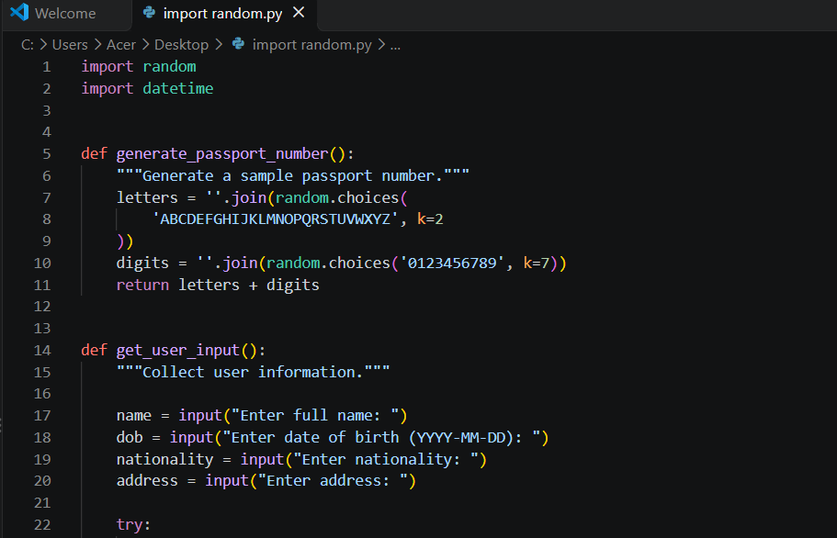
11. COMPLETE SOURCE CODE
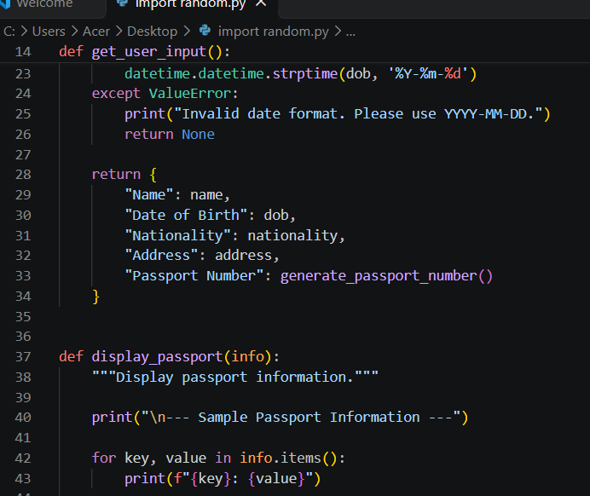

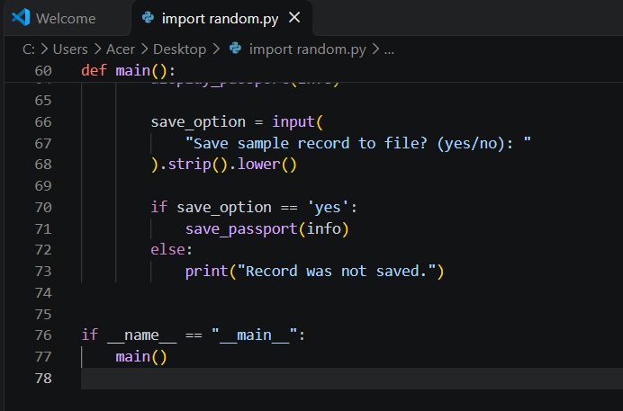
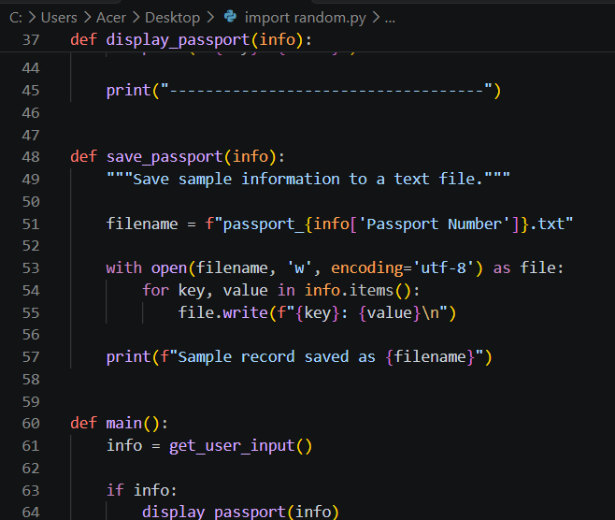

12. DETAILED CODE EXPLANATION

12.1 Importing modules
import random provides random selection functions. import datetime provides date and time classes. Both are included with Python, so no pip installation is needed.

12.2 Function definition
def creates a function. The program defines separate functions for generating an identifier, collecting data, displaying the record, saving it, and coordinating the workflow.

12.3 random.choices()
random.choices(sequence, k=n) chooses k items from a sequence with replacement. In this program it chooses two uppercase letters and seven digits. Since selection is random, the same identifier can theoretically occur more than once.

12.4 String join()
''.join(...) joins the selected characters into a single string without spaces. The letters and digits are then combined with letters + digits.

12.5 input()
input() displays a prompt and returns what the user types as a string. The current program does not prevent blank names, nationality, or address.

12.6 try and except
The try block attempts date parsing. If Python cannot parse the supplied date, it raises ValueError, which is handled by except. The program then prints an error and returns None.

12.7 strptime()
datetime.datetime.strptime(dob, '%Y-%m-%d') expects a date such as 2003-06-15. %Y means four-digit year, %m means month, and %d means day. It also rejects impossible calendar dates such as 2003-02-30.

12.8 Dictionary
The returned dictionary stores each label and its value. For example, 'Name' maps to the entered name, while 'Passport Number' maps to the generated sample identifier.

12.9 for loop and items()
info.items() returns key-value pairs. The for loop prints each pair in the display function and writes each pair in the save function.

12.10 f-strings
An f-string places variable values inside text using braces, such as f'{key}: {value}'. It is used for output lines and the filename.

12.11 File handling
open(filename, 'w', encoding='utf-8') opens a file for writing. Mode 'w' creates a new file or overwrites an existing file with the same name. The with statement closes the file automatically after the block.

12.12 strip() and lower()
strip() removes spaces at the beginning and end of the save choice; lower() converts it to lowercase so YES and Yes are treated as yes.

12.13 main guard
if __name__ == '__main__': main() runs the main function when the file is executed directly. It avoids automatically running the program if the file is imported as a module.

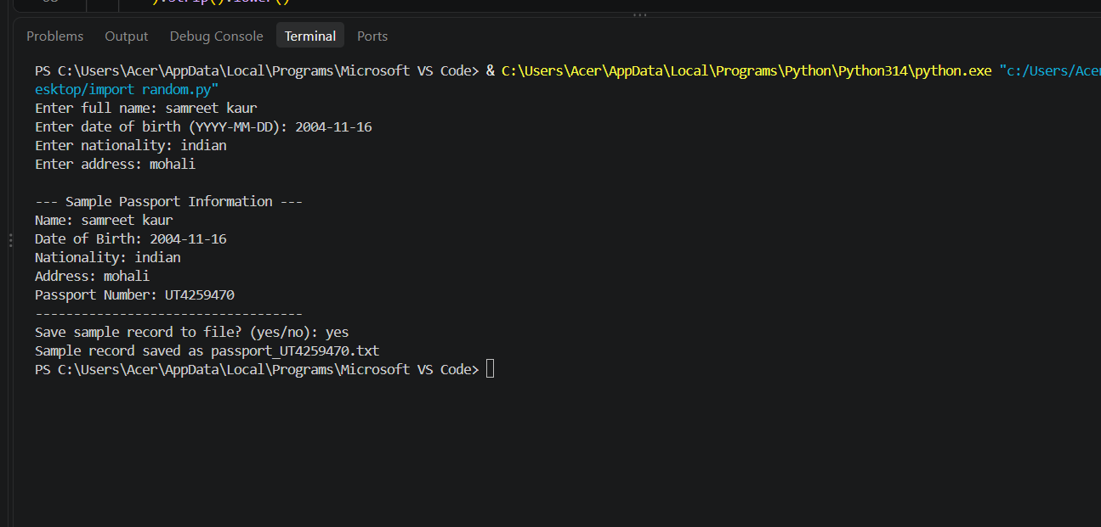
13. SAMPLE RUN AND OUTPUT

13.1 Example saved file
Name: Aman Kumar
Date of Birth: 2003-06-15
Nationality: Indian
Address: Chandigarh
Passport Number: AB1234567
The saved file is created in the current working directory—the directory from which the Python script is run, unless the editor sets a different working directory.

14. FILE HANDLING
File handling lets the program store output beyond the current terminal session. In this project, the filename is built from the generated sample identifier. The file is opened in write mode and each dictionary entry is written on its own line.

14.1 Benefits
- The user can open the record later in a text editor.
- The program avoids requiring a separate database for a single sample record.
- UTF-8 encoding supports a wide range of text characters.

14.2 Important limitation
The text file contains plain text and is not encrypted. Do not use real sensitive identity details in an unprotected demo file. Also, write mode can overwrite a file if a filename collision occurs. A production application would need stronger storage design, access control, error handling, and privacy safeguards.

15. TESTING AND TEST CASES
Test ID | Test / Input | Expected result | Reason
TC-01 | Valid date: 2003-06-15 | Record is created and displayed. | Checks normal processing.
TC-02 | Wrong format: 15-06-2003 | Invalid date message; no record is created. | Checks format validation.
TC-03 | Impossible date: 2003-02-30 | Invalid date message; no record is created. | Checks calendar validation.
TC-04 | Save choice: yes | Text file is created. | Checks file-writing branch.
TC-05 | Save choice: no | Record is not saved. | Checks not-saving branch.
TC-06 | Save choice: YES | Text file is created. | Checks lowercase normalization.
TC-07 | Blank name or address | Current code accepts the blank field. | Identifies a limitation for future improvement.
TC-08 | File-writing permission problem | The current code may raise an error. | Shows why file exception handling could be added.
Testing note: These are planned/manual test cases based on the code logic. Run the program with each input to confirm behaviour on your own computer. TC-07 and TC-08 intentionally document current limitations.

16. ADVANTAGES
- Beginner-friendly and easy to read.
- Uses only Python's standard library.
- Uses functions to organize the program into separate tasks.
- Validates the date format and calendar date.
- Displays output in a consistent structure.
- Offers optional saving to a text file.
- Demonstrates core concepts in a practical project.
- Can be extended with a GUI, database, and stronger validation.

17. LIMITATIONS
- The generated identifier is random and is not an official passport number.
- There is no connection to a government passport system or database.
- The program does not verify identity, nationality, or eligibility.
- It accepts blank fields and does not check the plausibility of personal details.
- The random identifier may theoretically be duplicated.
- The program has no graphical user interface.
- The output file is plain text and not encrypted.
- File-writing errors are not handled.
- A non-'yes' response is treated as no, even if the user enters an unclear response.

18. SECURITY, PRIVACY, AND ETHICAL CONSIDERATIONS
Names, dates of birth, and addresses are personal information. For classroom demonstrations, use fictional details. If real information is used with permission, store it only where necessary and protect the file from unauthorized access. Do not share the output publicly. The sample number must be labelled as a demo identifier and must never be presented as an official passport number.
The Python random module is suitable for simple demonstration values but is not designed for secure identifiers. For this educational project, the number is not intended to provide security, prove identity, or authorize travel.

19. FUTURE SCOPE
- Add validation to reject blank entries and trim unnecessary spaces.
- Ask again when a date is invalid instead of ending record creation.
- Validate the save response and repeat the prompt for anything other than yes/no.
- Add try/except handling for file errors and display a helpful message.
- Use a clearly labelled DEMO identifier to avoid confusion with an official passport number.
- Build a simple graphical interface with Tkinter.
- Store multiple demonstration records in a local database for learning purposes.
- Add search, update, and delete operations for sample records.
- Create automated unit tests for each function.
- Add safer data-storage practices if the project is adapted for a legitimate, authorized use.

20. CONCLUSION
The Passport Generator Using Python mini project demonstrates the practical use of fundamental programming concepts in a single console application. It collects user input, validates the date of birth, creates a random sample identifier, organizes details in a dictionary, displays the record, and optionally writes it to a text file. The project meets its educational aim of showing how functions, conditions, loops, exception handling, built-in modules, and file operations work together. It can be extended with better validation, automated testing, a graphical interface, and more secure storage. The generated record remains a demonstration only and is not an official passport or identity document.

21. LEARNING OUTCOMES
- Learned how to write and call functions in Python.
- Learned how to collect input from the keyboard.
- Learned to validate dates with the datetime module.
- Learned to generate random strings using random.choices().
- Learned to store related information in a dictionary.
- Learned to use loops and conditional statements.
- Learned to save data to a text file with open() and a with statement.
- Learned how to identify test cases and describe software limitations.
- Learned why privacy and clear demo labelling matter when working with personal information.

23. REFERENCES
- Python Software Foundation, random — Generate pseudo-random numbers: https://docs.python.org/3/library/random.html
- Python Software Foundation, datetime — Basic date and time types: https://docs.python.org/3/library/datetime.html
- Python Software Foundation, Built-in Functions: https://docs.python.org/3/library/functions.html
- Python Software Foundation, Reading and Writing Files: https://docs.python.org/3/tutorial/inputoutput.html
- Python Software Foundation, Errors and Exceptions: https://docs.python.org/3/tutorial/errors.html

